Bluetooth based Home Automation System

Musthiri Sajna
School of Computer Science and Engineering

Dr Shen Zhiqi
School of Computer Science and Engineering

Abstract - People, especially elders, find it troublesome to operate switches in their homes manually. They have to walk every time to turn on/off electronic devices like lamps. This is also risky if they walk in dark to operate the switches. For solving this problem, we are building a home automation system, a remote controller that allows users to control the home appliance switches connected to the controller using their smartphones via Bluetooth. The controller can be connected to any Android device having Bluetooth.
For building the remote controller, a Bluetooth module and relay module is connected in a breadboard. The external wires of electronic devices are connected to the relay module which is then controlled by a microcontroller, Arduino UNO. Bluetooth is programmed to operate the switches. For building the receiver, an application is developed that is programmed to control the functions in the Bluetooth module in the remote controller. When users specify which electronic device to be powered on or off a switch in the mobile application, wireless signals are sent from the smartphone via the mobile application and received by the Bluetooth module set up at the remote controller end. The Bluetooth module transmits these signals to the receiver end of the Arduino UNO which then decides which electronic device connected to turn on/ off based on the user input. The remote controller and the mobile application work together to enable the user to turn on/off any switch connected to the controller.

Keywords – Home automation system, Arduino UNO, Relay Module, Bluetooth Module.

INTRODUCTION
From the last decade onwards, home automation has gained great popularity [1]. Home automation refers to automatic and electronic control of home appliances. It is the feature that brings the “Smart Home” concept. Nowadays, smartphones are used to control the home features as it the most convenient way.
For building a home automation system, we focus on using an Arduino board, Arduino UNO as a microcontroller for the system.
Arduino is an open-source electronics platform that is easy to use hardware and software. There are several other ways of creating a home automation system like using another microcontroller like Parallax basic stamp which serves the same purpose. But these are messy and complex to program and integrate with other devices such as the Bluetooth and relay modules. Arduino is suitable for naive and expert users and it is supported on cross-platform. This means that the Arduino Software (IDE) can run on various operating software such as Windows, Macintosh OSX and Linux. Hence, in this research paper, we use Arduino as a microcontroller in building the remote controller [2].
In the home automation system built in this research, users control the remote controller using the mobile application specifically built for operating the home automation system that is the remote controller.
- METHODOLOGY
The remote controller in this research is developed using the following hardware devices.
2.1 ARDUINO UNO
Arduino Uno is a microcontroller from the Arduino family that is used in this research. This specific version is used because it has everything needed to support the controller. It has 6 input/output pins, a USB connection, a power jack and a reset button. The output signals for the home switches can be connected to any of the 2-13 pins, pin 0 is connected to the receiving end and pin 1 is connected to the transmitting end of the Bluetooth module. Power is supplied to the Arduino Uno by connecting it with a USB cable to a computer or an AC-DC adapter [3].
To receive signals from the user via Bluetooth module and transmitting required signals to home appliances, the Arduino Uno is configured using Arduino Software (IDE). The Arduino Software (IDE) is used to write code in C++, compile and upload it to the board. Once the code is uploaded to the board, it is saved to the flash memory of the Arduino Uno and will be retained in the memory even if no power supplied.
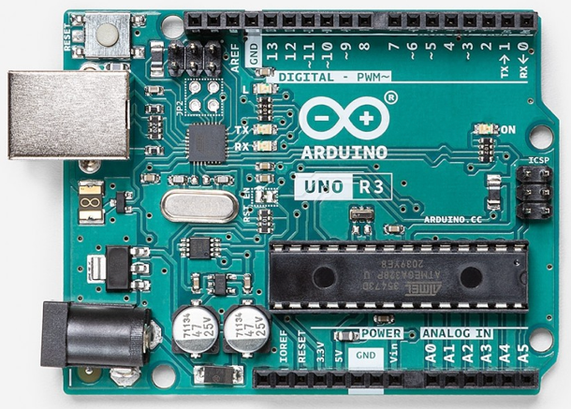
Figure 1: Arduino Uno

2.2 RELAY MODULE
A relay module is an automated switch that controls a high-frequency current circuit with a low-current signal. As it is an automated switch, it can be used in a home automation system.
In this research, a relay module with four channels is used. Each channel can be connected to a circuit of high voltage. Hence the relay module in this research can support up to four home appliances. To connect a 220V LED light to the relay module, part of the hot wire of the LED light should be connected to the NO (Normally Open) terminal of the relay module and the other part connected to the 220V power supply. The COM (common) terminal is connected directly to the 220V power supply. This completes the circuit at the relay module and device end. According to the signal passed to the relay module, the switch at the channel opens or closes the circuit that turns on/off the LED light.
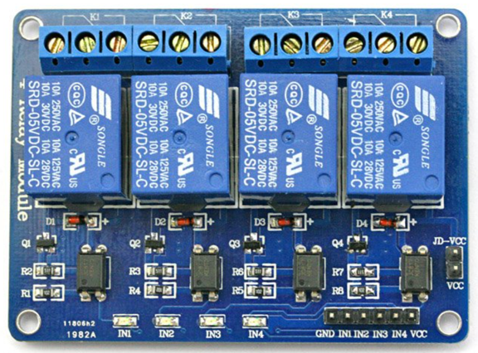
Figure 2: Relay Module

2.3 BLUETOOTH MODULE
In this research, the HC-05 Bluetooth module is used. This module is designed for wireless transparent communication. It a master-slave device. It is pre-configured as a slave device. When this Bluetooth module is paired with a master device such as a smartphone, all data sent from the smartphone is received through the serial input pin. The received data is then transmitted through Arduino wire connected to pin 0 of the Arduino Uno.
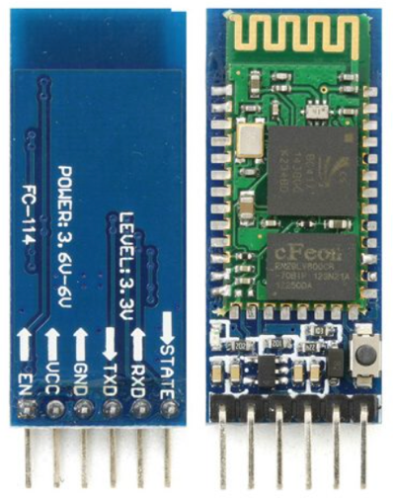
Figure 3: Arduino Uno

PROCEDURE
On building a Bluetooth based home automation system that consists of a smartphone, assembling of hardware devices and software configuration of devices are required.

3.1 HARDWARE
For controlling the switch functions, the relay module is connected to the Arduino Uno. At the relay module end, all the circuit connection are made as mentioned in section 2.2. The pins IN1, IN2, IN3 and IN3 of the relay module are then are connected to any of the input pins 2-13 of the Arduino Uno. Once a signal to any of the pins IN1, IN2, IN3 and IN3 is obtained, the circuit of the home device completes and turns on.
For receiving signals from a user via Bluetooth, the Bluetooth module is connected to the Arduino Uno. As mentioned in section 2.3, the receiving pin of the Bluetooth module is connected to the transmitting pin of Arduino Uno and vice-versa. According to the signal received from the Bluetooth module, Arduino Uno sends the corresponding signals to the relay module to turn on/off the switches.
The steady power of 5V to the relay module and Bluetooth module is supplied from the Arduino Uno. The Vcc and GND pins of both the modules are connected to the 5V and GND pins of the Arduino Uno. The power to Arduino Uno is obtained by connecting it to a computer or AC-DC Adapter via a USB Cable.
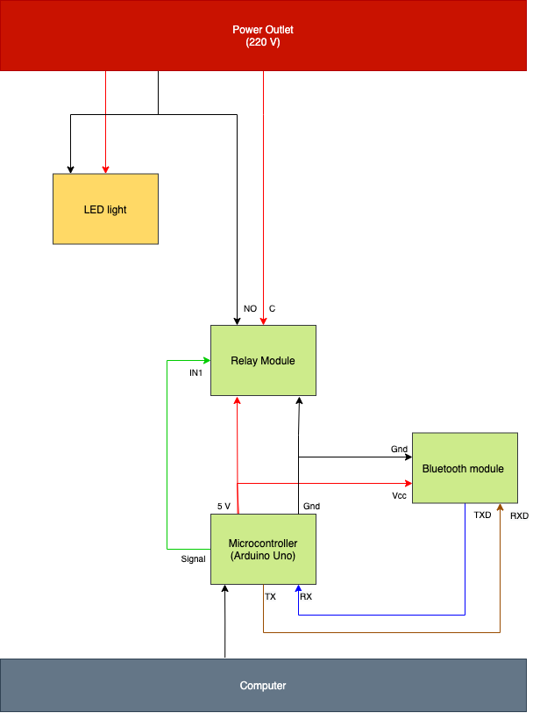
Figure 4: Circuit Diagram

3.2 SOFTWARE
Arduino Software (IDE): It is open-source software and is used for programming the Arduino board. This software works in Windows, Mac OS X and Linux operating systems.
Code is written and uploaded to the Arduino board. The code is to configure the input pins and send high or low signals to the relay modules based on the signals received from the Bluetooth module. The code can be found in the appendix.
Mobile Application: An android mobile application is made using MIT App Inventor. MIT App Inventor is a web application integrated development environment. An android application is built that pairs up with the Bluetooth module and sends text signals to the Arduino board through the Bluetooth module.
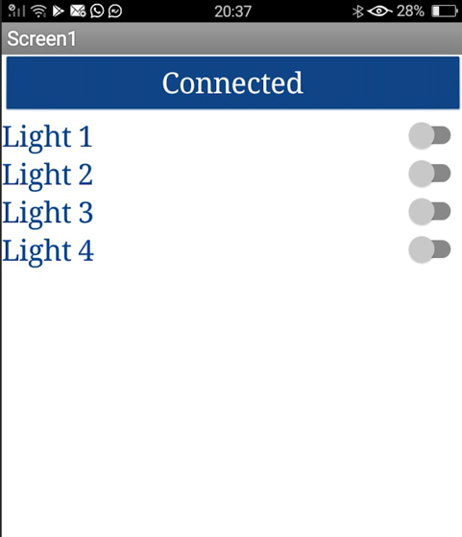
Figure 5: Mobile Application (Lights turned off)

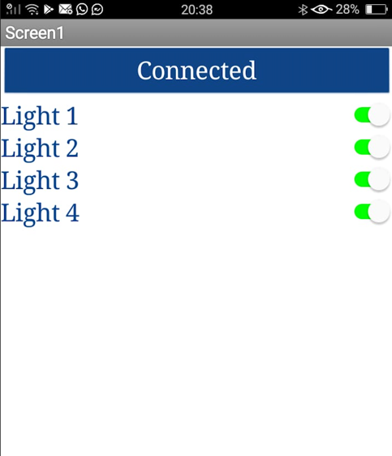
Figure 6: Mobile Application (Lights turned on)

3.2 TEST
All the connections are completed without the power supply. For testing, high power is expected to be supplied to one end of the relay module and the home device such as an LED light. Home appliances are usually powered at 220V or 110V. Such high voltages are dangerous so for testing, a 5V power supply is used for the LED light. Steady power of 5V is supplied to the other end of the relay module and Bluetooth module from the Arduino Uno by connecting it to a computer. At this stage, all connections are completed and the system is waiting for signals from the user via the Bluetooth module.
In the Android mobile application, the user connects to the Bluetooth module and selects the LED lights to be turned on or off. According to the selection, the signals are transmitted to the Bluetooth module which then re-transmits the signal to the Arduino Uno. Per the uploaded code, the Arduino Uno sends high or low signals to the relay module which then turns on or off the switches. Thus, the LED lights specified by the user turns on or off.
The tests can be conducted anywhere with a steady power supply. For this research, the tests were conducted in a lab. The test results obtained was as predicted from the theory and all the devices worked as expected. There were no anomalies. The 5V powered LED lights turned on/off, without any noticeable delays, in response to the actions in the smartphone. Thus, the experiment was successful.
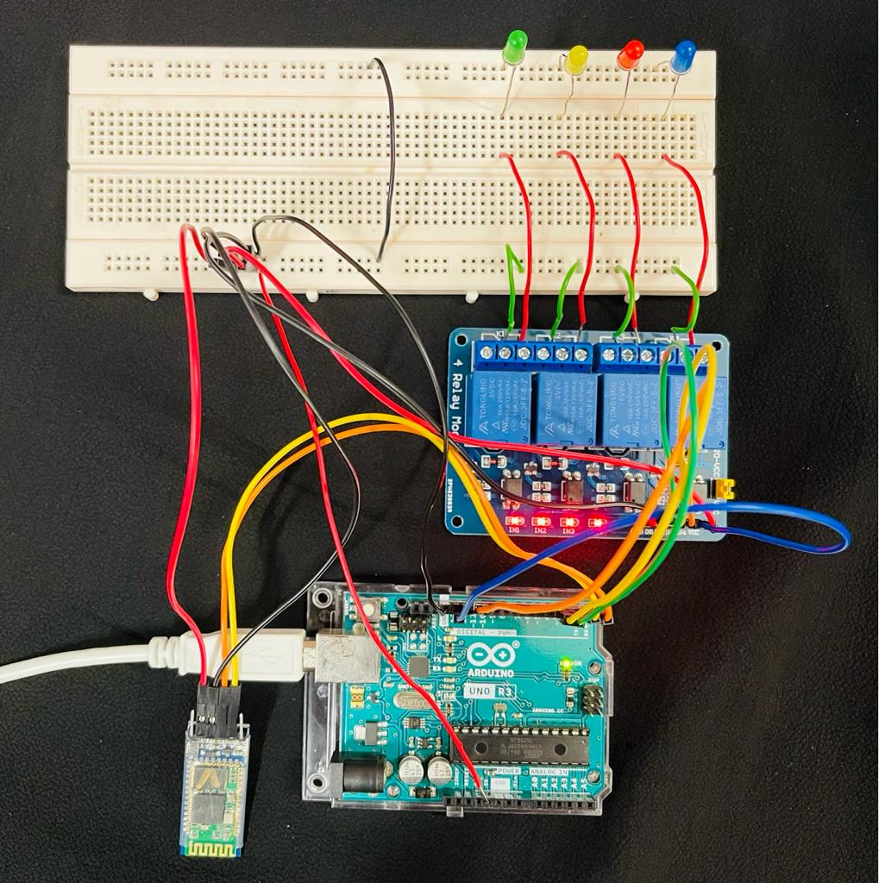
Figure 7: Remote Controller Setup

FUTURE SCOPE OF PROJECT

4.1 VOICE RECOGNITION
The voice recognition-based model provides a more user-friendly interface. It has the same circuit diagram at the hardware end. No further changes need to be made to the connections or devices. It works with Bluetooth. Voice recognition is an extra feature that can be added to the mobile application. In the mobile application, by converting voice messages to text messages and sending the converted text signals to the controller, the same functions can be achieved. Researches are required for retaining accurate voice messages and cancelling the noise (unwanted signals).

4.2 Internet of Things (IoT)
The internet of Things (IoT) is a system of interrelated devices that transfers data over the network. It is an important area for future technologies.
The main disadvantage of Bluetooth based systems is the limited range of Bluetooth. By connecting directly to the internet, the system can be managed by smartphones. Users can operate the home appliances using the internet with the help of Wi-Fi modems. Wi-Fi interfaces the system to the internet and it has a wider range than Bluetooth. IoT is a growing field in the industrial and research field. It can be implemented by adding new features to the controller.

- CONCLUSION
Home automation is a relevant and growing field in future technologies. New methods and improvements are researched and added every day. In this paper, the suited devices to build a home automation system are discussed and the ways of building it.
Home automation also has a vast future scope. New technologies can be incorporated into this model to make homes smarter. This design can be further expanded from homes to cities with the help of IoT. This exploration of home automation will hopefully inspire more research in the advancement of home automation systems.

- ACKNOWLEDGEMENT
I would like to express my special thanks of gratitude to my URECA supervisor, Dr Shen Zhiqi for his guidance valuable insights and Zhang Huiguo for his assistance throughout the process.
I would like to acknowledge the funding support from Nanyang Technological University – URECA Undergraduate Research Programme for this research project.

- REFERENCES
[1] S. Marandi, T. K. Mahato, D. Paul, K. Rupam, M. Kumari, P. Kumar, S. Basu, and S. K. Gouda, “Overview on Home Automation System in IoT Environment,” SSRN, 18-Sep-2020.
[2] “Arduino - Introduction,” Arduino.cc. [Online]. Available: https://www.arduino.cc/en/guide/introduction.
[3] “Arduino Uno Rev3,” Arduino.cc. [Online]. Available: https://store.arduino.cc/usa/arduino-uno-rev3.
[4] shedboy, “5 Volt 4 Channel Arduino Relay Module example,” Arduinolearning.com, 02-Jan-2017. [Online]. Available: http://arduinolearning.com/code/5-volt-4-channel-arduino-relay-module-example.php.
[5] “Bluetooth module HC-05 , serial TTL ‘most popular,’” Ram-e-shop.com, 08-Sep-2018. [Online]. Available: https://ram-e-shop.com/product/kit-bluetooth-hc05/.
[6] “Software,” Arduino.cc. [Online]. Available: https://www.arduino.cc/en/software.
[7] “About Us,” Mit.edu. [Online]. Available: https://appinventor.mit.edu/about-us.
[8] I. Lee and K. Lee, “The Internet of Things (IoT): Applications, investments, and challenges for enterprises,” Bus. Horiz., vol. 58, no. 4, pp. 431–440, 2015.
[9] Aakashkumar, “PROJECT REPORT ON Home automation using by Bluetooth,” Slideshare.net. [Online]. Available: https://www.slideshare.net/Aakashkumar276/project-report-on-home-automation-using-by-bluetooth.
[10] S. Campbell, “Turn any appliance into a smart device with an Arduino controlled power outlet,” Circuitbasics.com, 19-Nov-2015. [Online]. Available: https://www.circuitbasics.com/build-an-arduino-controlled-power-outlet/.

- APPENDIX
This appendix contains some useful and relevant links for the software part of the home automation system.
- https://www.arduino.cc/en/software : Download the Arduino Software (IDE).
- https://github.com/SAJNA001/Bluetooth-based-Remote-Controller/blob/main/FINAL_TEST.ino : Download Arduino Software code
- http://ai2.appinventor.mit.edu/#5359408690626560 : Code for the Android mobile application (MIT app inventor)

